|  |  |  |  |
| --- | --- | --- | --- |
| Description: Description: S:\AdminShared\All Staff\1 College Logo's\Baldivis_Logo_colour.jpgName: | \_\_\_\_\_\_\_\_\_\_\_\_\_\_\_\_\_\_\_\_\_\_\_\_\_\_\_\_\_\_\_\_\_\_\_\_\_\_\_\_\_\_\_\_\_\_\_\_\_\_\_ | | Date: *\_\_\_\_\_\_\_\_\_\_\_* |
|  | **Year 11 Applications**  **Test 4, 2019**  **Topics – Matrices, Similar Figures and Scale Factor** | | 53  = % |
| **Total Time:** | ***56*** *minutes* |  | |
| **Total Reading:** | *3**minutes* |
| **Total Working:** | *53**minutes* |
| **Weighting:** | *7% of the year,14% of the semester.* |
| **Equipment:** | *SCSA Formula Sheet; 1 page notes (A4 one side,* ***Unfolded****), CASIO ClassPad; Scientific Calculator* | | |

**Resource Free Section – 25 min 1 min reading time [25 marks]**

**1. [5 marks= 2, 2, 1 ]**

**a)** What similarity test can be used to prove these triangles are similar? Justify your answer.

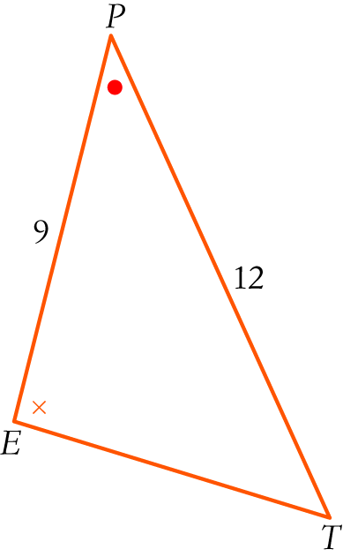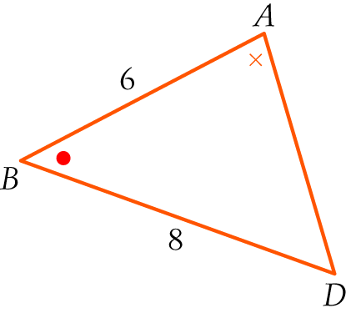

b) What scale factor has been used to change Δ*EPT* into Δ*ABD*?

**c)** If *ET* = 13.5, what is the length of *AD*?

**2. [4 marks= 1, 1, 1, 1]**

Given matrices A, B and C with dimensions

A: 2 × 1, B: 2 × 2 C: 2 × 3, respectively

State the dimensions of each of the following if they exist:

**a)** BA

**b)** BC

**c)** A + B

**d)** A2

**3. [3 marks= 1, 1, 1]**

Each of the matrices below can be identified as one or more of the types listed in the box. State which type(s) each matrix is.

|  |  |  |  |  |
| --- | --- | --- | --- | --- |
| row | column | square | identity | zero |

1. 
2. 
3. 

**4.** **[7 marks= 1, 1, 1, 2, 2]**

Calculate:

1. 

**b) **

**c)** 

**d)** 

**e)** 

**5. [2 marks=1, 1]**

Let  ,  , .

1. In the product matrices below, fill in the boxes (□) with the correct values.
   * 1. 
     2. 

**6. [4 marks]**

Given , . If *P* = *Q* find the values *w, x, y* and *z*.

**Resource Section – 28 min 2 min reading time NAME: \_\_\_\_\_\_\_\_\_\_\_\_\_\_\_[28 marks]**

**7. [9 marks =2, 2, 3, 2 ]**

**a)** A map of NSW has a scale factor of 1 : 2 250 000. If a straight line

drawn between Mudgee and Wellington is 27 mm long, how far apart are the two cities?

**b)** The floor plan of the hall has a scale of 1 : 300.

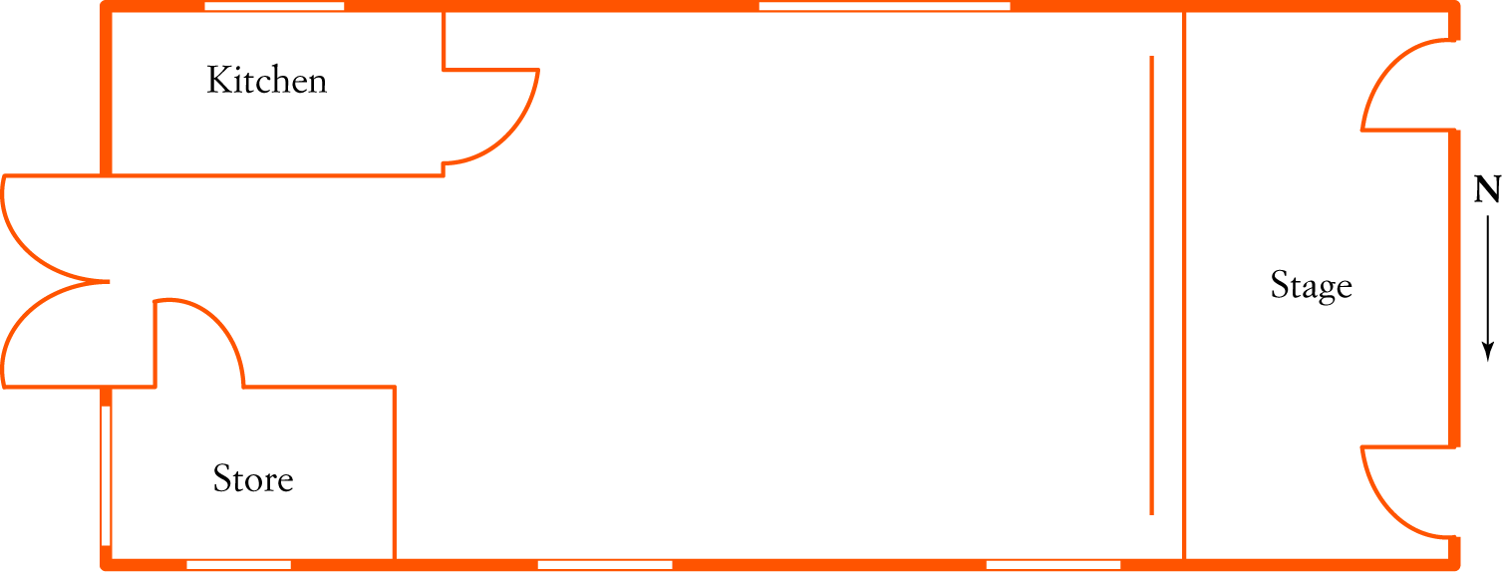

**i)** What are the dimensions of the stage?

**ii)** What is the area of the store room floor?

**iii)** Shelving is to be built along one wall of the kitchen. If the

shelving is 4.5 m long, what length of drawing would represent it on the plan?

**8. [2 marks]**

Henry holds a 30 cm ruler and measures its shadow to be 24 cm. At the same time, Julia measures the shadow of a lamp post to be 10.5 m long. How tall is the lamp post?

**9. [3 marks= 1, 2]**

During the school holidays the cinemas put on special programs for children. A cinema runs three sessions. The attendance figures for Monday are 150, 160 and 70 adults at morning, afternoon and evening sessions respectively and 250, 310 and 180 children for each of the sessions. The charges are $11 for adults and $6 for children.

1. Construct and clearly label matrix A to show the attendance for each session on Monday.

**b)** Use matrices to find the total box office receipts for each session on Monday. While you may use your CAS to carry out the matrix operation required, make sure you write down the matrices and show which matrix operation you used.

**10.** **[10 marks= 2, 2, 2, 2, 2]**

The diagram below shows the road routes between the 5 towns A, B, C, D and E.

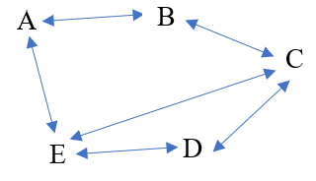

1. Represent the above information in a one-way matrix, denoted by the letter M.
2. Construct a two-way matrix to find the number of routes between any two towns via another town.
3. Use the matrix method to find the number of routes between any two towns via two towns.
4. Determine the matrix M + M2
5. What information is given by the matrix M+ M2

**10.** **[3 marks]**

The two shapes below are similar. Find the ratio of the smaller area to the larger area.

24mm

4.5cm